Critical evaluation
Performance under load
Request rate
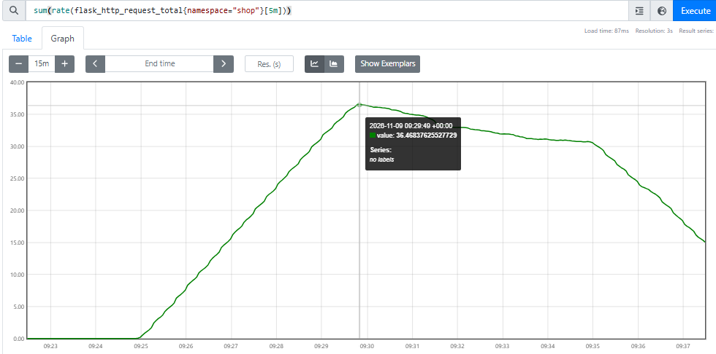

p50 / p95 / p99
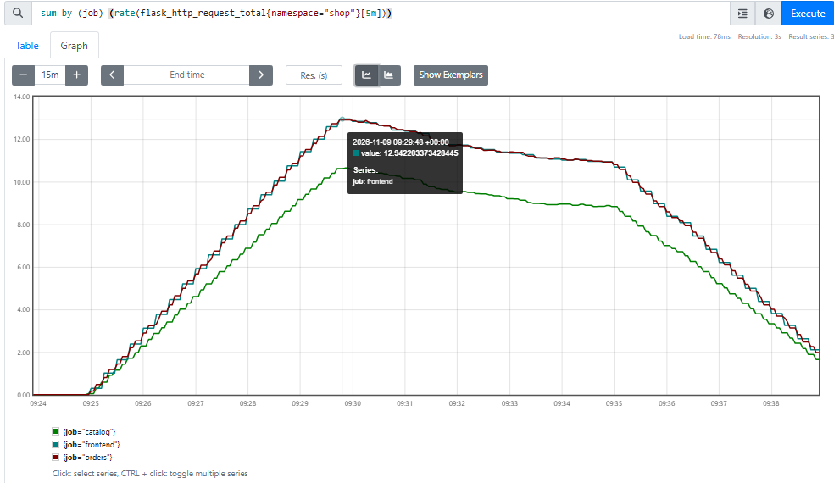
Total traffic peaked at about 36 req/s . Frontend and orders each handled about 13 req/s and catalog about 11. Catalog was lower, which fits orders skipping it on cache hits

Error ratio
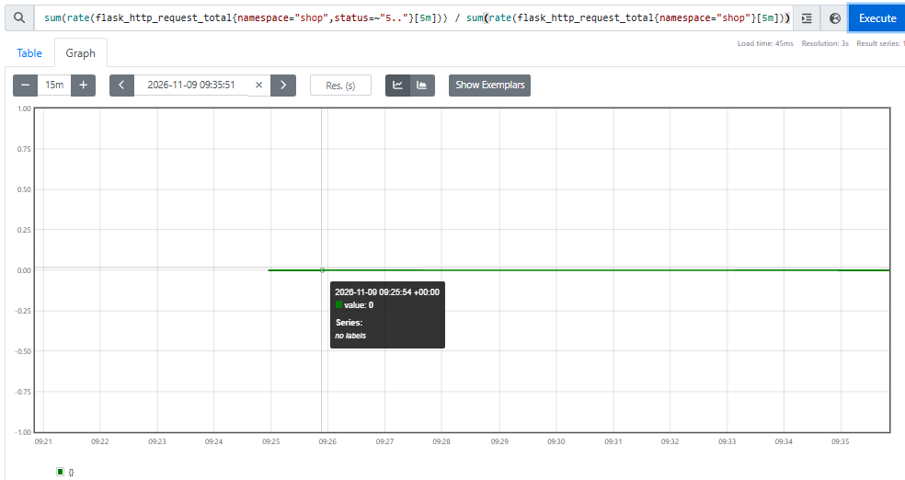

The 5xx ratio stayed at 0 throughout. There were no server errors under load.
CPU per pod
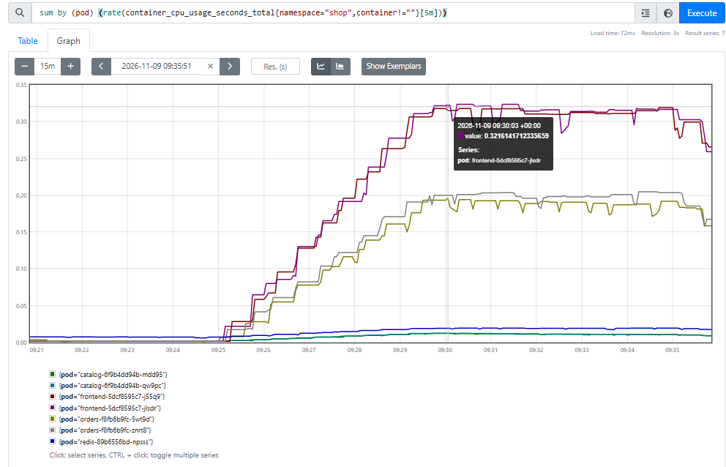

CPU throttling
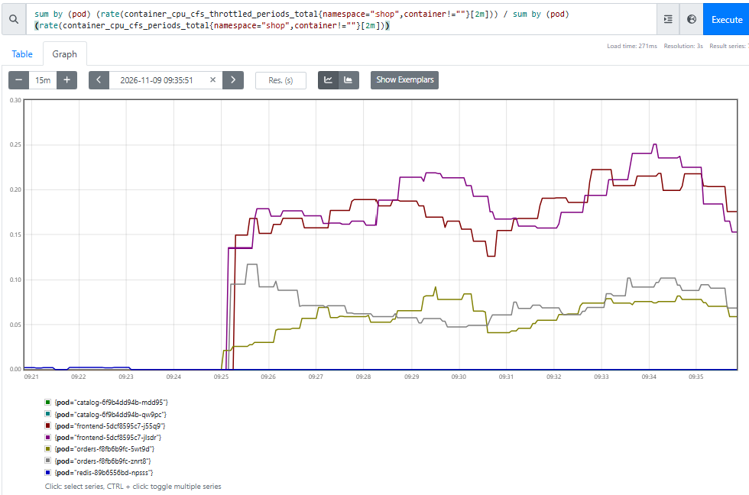

Memory vs limit
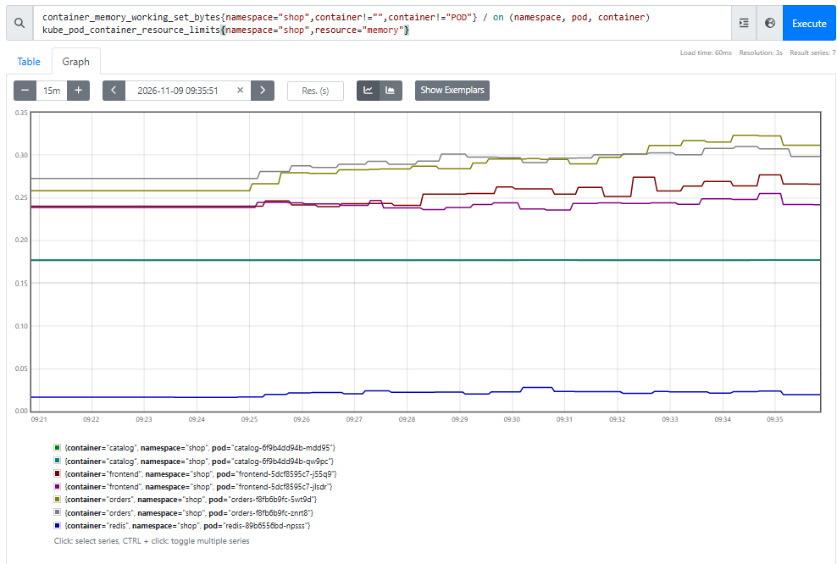
No memory pressure. Orders was highest at about 32% of its limit, frontend 25%, catalog 18% and Redis 2%.

Cache hit ratio
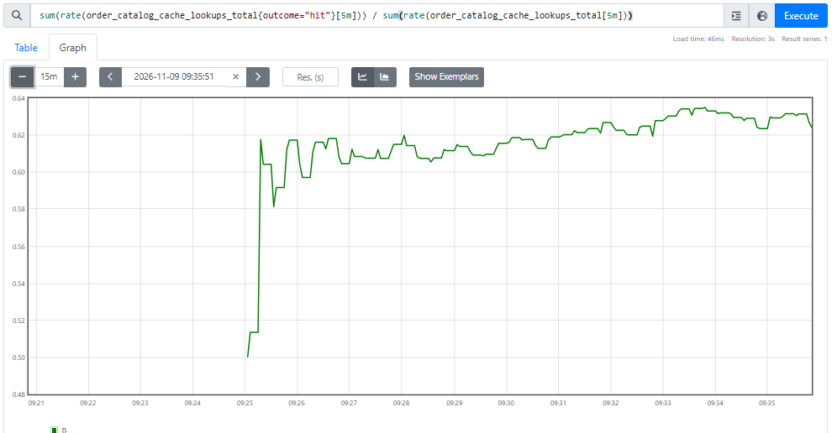
First to degrade: the frontend. Its two Pods used about 0.32 cores against a 0.5 core limit (64%), the highest of any service. Orders used about 0.2 (40%), and catalog and Redis almost nothing. The frontend was also throttled in 17 to 25% of scheduling periods against 5 to 10% for orders and about 0 for catalog and Redis. A throttled container is paused until the next period, so latency rises even when average CPU looks comfortable. Total throughput also eased from about 36 to 31 req/s with the same 8 clients, which fits requests slowing down.

Behavior under failure
A: catalog scaled to 0. The page still loaded over HTTPS. The catalog section said the service was not responding, and the order form was replaced with “Unavailable while the catalog service is down”. The replicas panel shows catalog ready dropping to 0 while orders and Redis stayed up. Orders was the only service with 5xx errors (a spike of about 0.5%). The frontend stayed at 0%.
B: Redis scaled to 0. The page still loaded, and the product list and order form were normal. Only the Orders section changed, to “the order service is healthy, but its datastore is unreachable”.
Why they differ. In A the product list and ordering were lost. In B only order history and new orders were lost, and the product list was untouched. The page can tell them apart because the frontend tracks the order service and its datastore separately.
Design choices that produced this:
- fetch_products() and fetch_orders() return a success flag instead of raising, so one dead dependency disables one feature, not the whole page.
- The /healthz probe doesn’t check Redis or catalog. If it did, Redis going down would fail readiness on both orders Pods at once, the Service would have no endpoints, and the frontend would get a connection error instead of the handled message.
- The Redis client has no retries and 1s timeouts, so with Redis down orders answers quickly instead of hanging and being wrongly reported as down.
Graceful degradation, not outage. In both cases the site stayed up and every other feature worked. An outage would show as the page failing or the frontend’s error ratio rising. The dashboard shows the difference: ready replicas and the orders 5xx moved, and the frontend’s error ratio stayed at 0.

Scaling
catalog scaled from 2 to 5. Three new Pods started and joined the Service as soon as they passed readiness. kubectl get endpoints catalog listed all five IPs, and the replicas panel showed 5 desired and 5 ready. The existing Pods, frontend, orders and Redis were not restarted. Of 30 test requests, all five catalog Pods answered.
Nothing else had to change. No manifest was edited, nothing was restarted, and the frontend wasn’t told. The Service finds Pods by label, so new ones are picked up automatically.
What I’d scale first: the frontend. Under load it was closest to its CPU limit and the most throttled, while catalog used almost no CPU. More catalog replicas would add capacity that wasn’t needed.
The limit on a single node. Every replica shares one 2 vCPU, 8 GiB VM, which also runs the monitoring stack. The scheduler places Pods by their resource requests, so once the node’s memory is fully requested, new Pods stay Pending. CPU is shared between all Pods too.
Scaling adds throughput, not availability. All replicas share one VM, one disk and one kubelet. If the VM dies, every replica dies with it. The fix is more nodes, which is a different architecture and a bigger bill.

Reflection
Weakest point 1: a single node. The control plane, workloads, Redis and monitoring all run on one VM. If it fails, the whole shop goes down, and extra replicas don’t help because they share that VM. Node updates and reboots also cause downtime.
Fix: run three or more nodes, either self-managed or on a managed Kubernetes service. Pods spread across nodes, so losing one node leaves the shop running. Cost: roughly three times the compute bill.
Weakest point 2: Redis as a single-replica Deployment. The PVC kept the orders when I deleted the Pod (Experiment D), so data survives, but nothing else does. While Redis is down, no orders can be placed or listed (Experiment B). The Recreate strategy also means every update causes a gap. A Deployment has no stable identity for each replica, so it can’t run a replicated database.
Fix: use a StatefulSet with a primary and replica and automatic failover (for example Redis Sentinel), or a managed Redis service. Cost: more complexity, at least double the memory, and shared storage that works across nodes.

